**DAILY ONLINE ACTIVITIES SUMMARY**

|  |  |  |  |  |  |  |  |
| --- | --- | --- | --- | --- | --- | --- | --- |
| **Date:** | **12-06-2020** | | | | **Name:** | **Veekshith Shetty** | |
| **Sem & Sec** | **8th sem B sec** | | | | **USN:** | **4AL16CS097** | |
| **Online Test Summary** | | | | | | | |
| **Subject** | | **BDA** | | | | | |
| **Max. Marks** | | **30** | | **Score** | | **25** | |
| **Certification Course Summary** | | | | | | | |
| **Course** | **AWS LAMBDA foundation** | | | | | | |
| **Certificate Provider** | | | **Aws** | **Duration** | | | **1hr** |
| **Coding Challenges** | | | | | | | |
| **Problem Statement- #Python program to reverse words in string** | | | | | | | |
| **Status: completed** | | | | | | | |
| **Uploaded the report in Github** | | | | **yes** | | | |
| **If yes Repository name** | | | | **Supriksha** | | | |
| **Uploaded the report in slack** | | | | **yes** | | | |

Online Test Details: (Attach the snapshot and briefly write the report for the same)

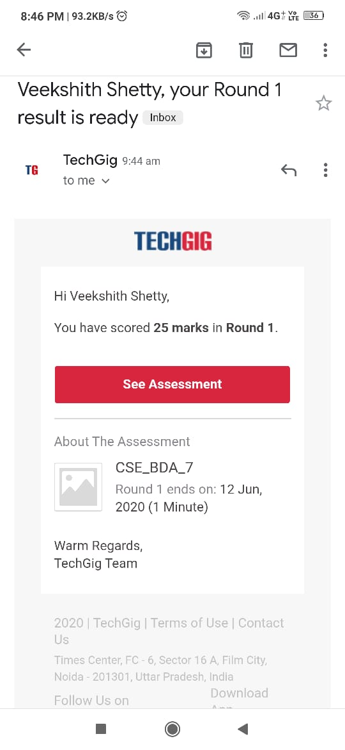

Certification Course Details: (Attach the snapshot and briefly write the report for the same)

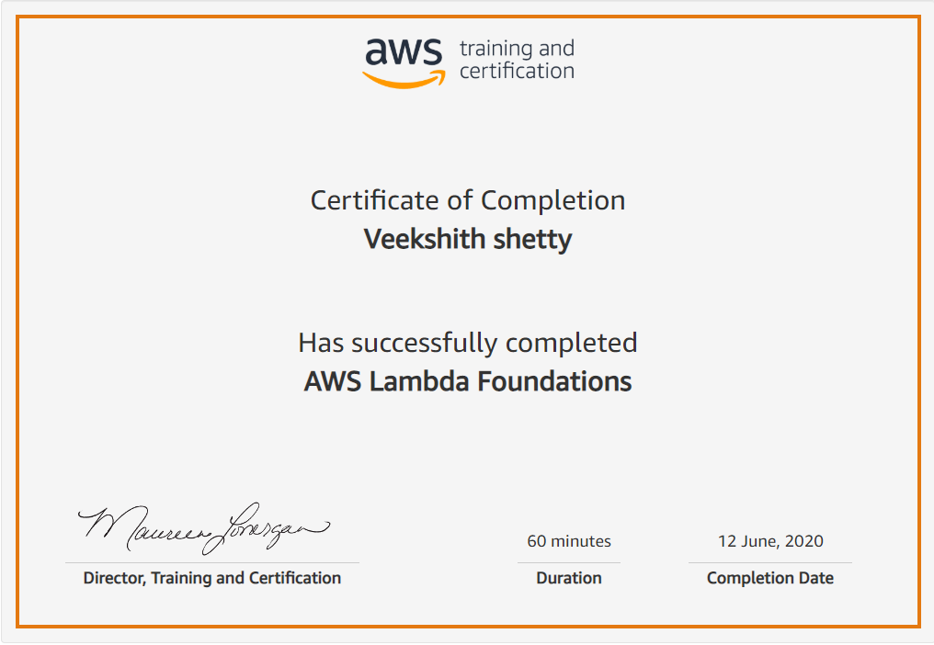

Coding Challenges Details: (Attach the snapshot and briefly write the report for the same)

Coding was given and it was uploaded for github and slack

**def reverse_string_words(text):**

**for line in text.split('\n'):**

**return(' '.join(line.split()[::-1]))**

**print(reverse_string_words("The quick brown fox jumps over the lazy dog."))**

**print(reverse_string_words("Python Exercises."))**